ST. PATRICK KIGULU GIRLS’ BOARDING PRIMARY SCHOOL
REVISION EXERCISE
PRIMARY FOUR INTEGRATED SCIENCE 2020
NAME: _______________________ DATE: ____________
SECTION A (40 MARKS)
- Name the body organ a goat uses for smelling.
……………………………………………………………………….
- Give any one common accident children get at home.
……………………………………………………………………….
- What body parts are affected by trachoma?
……………………………………………………………………….
- Mention any one process involved in water cycle.
……………………………………………………………………….
- Identify the type of weather good for winnowing.
……………………………………………………………………….
- How can a farmer prevent rusting of metallic garden tools?
……………………………………………………………………….
- What is the benefit of boiling drinking water?
……………………………………………………………………….
- Why is loam soil the best type of soil for crop growing?
……………………………………………………………………….
- State one characteristic of insect pollinated flowers.
……………………………………………………………………….
- Name any one food stuff prepared by roasting before eating.
……………………………………………………………………….
- Mention any one bird kept at home as a pet.
……………………………………………………………………….
- What is transplanting?
……………………………………………………………………….
……………………………………………………………………….
- How does a caterpillar move?
……………………………………………………………………….
- What food value is got from eating fish?
……………………………………………………………………….
- Apart from bathing daily, how else can a P.4 child keep proper personal hygiene?
……………………………………………………………………….
- Mention one requirement for burning of wood.
……………………………………………………………………….
- Which type of mosquitoes spread malaria?
……………………………………………………………………….
- Identify any one use of sun in the environment.
……………………………………………………………………….
- State the importance of wind sock at a weather station.
……………………………………………………………………….
- Draw a leaf to show parallel leaf venation in the space below.

- Why is it dangerous to play with electricity?
……………………………………………………………………….
- Give one importance of smoking ordinary latrines.
……………………………………………………………………….
- Apart from oxygen, what other thing do people get from the process of photosynthesis?
……………………………………………………………………….
- Mention any one example of leguminous crops.
……………………………………………………………………….

- What is the young one of a horse?
……………………………………………………………………….
- Name tool bees and wasps use for protection.
……………………………………………………………………….
- Besides babies, what other group of people need special care and attention?
……………………………………………………………………….
- Name the soil type with the roughest and largest particles
……………………………………………………………………….
- List any one item found in the first aid kit.
……………………………………………………………………….
- Identify the second stage of development in grass hoppers.
……………………………………………………………………….
- State the function of the heart in the human body.
……………………………………………………………………….
- When are we encouraged to brush our teeth?
……………………………………………………………………….
- Give the importance of proteins in our diet.
……………………………………………………………………….
- Describe any one way of controlling soil erosion in an area.
……………………………………………………………………….
- Name one group of people found in an extended family.
……………………………………………………………………….
- State any one use of the part of plant drawn below to the plant.
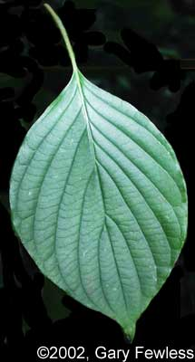
……………………………………………………………………….

- Which activity can a P.2 class perform during a physical education lesson using wind?
……………………………………………………………………….
- Write the function of the hygrometer at a weather station.
……………………………………………………………………….
- What is the importance of the rat guards on a granary?
……………………………………………………………………….
- State one importance of mushrooms to people.
……………………………………………………………………….
SECTION B
- a) Mention any two characteristics of true insects.
- …………………………………………………………………….
- …………………………………………………………………….
b) Why is a spider not regarded as a true insect?
……………………………………………………………………….
c) Apart from the spider, mention any one other insect not considered as true.
……………………………………………………………………….
- a) Write down any two causes of road accidents.
- …………………………………………………………………….
- …………………………………………………………………….
b) Give any two reasons for giving first aid to casualties.
(i) ……………………………………………………………………….
(ii) ……………………………………………………………………….
- Match the garden tools to their functions correctly.
Garden tools Functions
Spray pump For pruning
Hoe For transplanting seedlings
Trowel For spraying crops
Secateurs For uprooting cassava
- a) Which component of air has the highest percentage?
……………………………………………………………………….
b) How do people use carbon dioxide in the community?
……………………………………………………………………….
c) If the sun is in the morning hours, where will Job’s shadow be formed?
……………………………………………………………………….
d) Write any one use of shadows to people.
……………………………………………………………………….
- a) Mention any two ways in which learners at St. Mary’s Junior School Seeta maintain sanitation at the school.
- …………………………………………………………………….
- …………………………………………………………………….
b) Name any one tool commonly used when carrying the above activities.
……………………………………………………………………….
c) Identify any one disease that can result from poor sanitation.
……………………………………………………………………….
- List any two examples;
- Domestic animals used for transport.
(i) …………………………………. (ii) ………………………
- Wild animals eaten as food.
(i) …………………………………. (ii) ……………………….
- Describe how each of these parts is useful to an insect.
- Antennae
……………………………………………………………………….
- Wings
……………………………………………………………………….
- Spiracles
……………………………………………………………………….
- Eyes
……………………………………………………………………….

- The diagram below shows a flower. Use it to answer the questions that follow.
Y
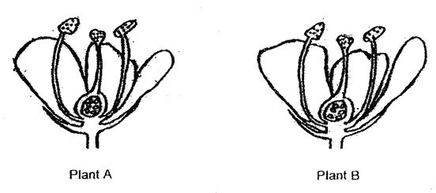
X
Z
- Why is part marked X brightly coloured?
……………………………………………………………………….
- Name the tube marked Z.
……………………………………………………………………….
- State the role played by part marked Y.
……………………………………………………………………….
- Using an arrow and letter K, show the stigma.
- a) List any two examples of natural changes that affect people negatively.
(i) ………………………………… (ii) ………………………………
- Identify any two examples of important things people get from swamps.
(i) …………………………….. (ii) ……………………………….
- In which two ways can you control the spread of;
- Malaria
- ………………………………………………………………….
- ………………………………………………………………….
- Cholera
- ………………………………………………………………….
- ………………………………………………………………….
- a) Describe any two ways in which you can care for plants in the compound.
- …………………………………………………………………….
- …………………………………………………………………….
b) State any two causes of soil erosion.
- …………………………………………………………………….
- …………………………………………………………………….
- a) What is a balanced diet?
……………………………………………………………………….
b) Mention any two ways of preserving food like fish.
(i) ……………………………………………………………………….
(ii) ……………………………………………………………………….
c) Name the deficiency as a result of lack of carbohydrates.
…………………………………………………………………………..
- a) Give the two main groups of living things in the environment.
(i) ………………………………….. (ii) ………………………………
b) Identify any two components of the soil.
(i) ………………………………….. (ii) ………………………………
- a) What type of clouds are very useful to crop farmers?
…………………………………………………………………………..
b) Mention any two conditions of weather.
(i) ………………………………….. (ii) ………………………………
c) What season is good for growing crops?
……………………………………………………………………….
- How do the following animals move?
- Fish ……………………………………………………………..
- Rats ……………………………………………………………..
- Snakes ……………………………………………………………..
- Frogs ……………………………………………………………..
END

